**WING LOAD CALCULATION**

(Example document for LSA applicants – v1 of 08.03.16)

|  |
| --- |
| Date of issue: DD/MM/YYYY  Document reference: ABCD-FL-57-00 |

|  |  |  |  |
| --- | --- | --- | --- |
|  | **Approval data** |  |  |
|  | **Prepared by** | **Verified by** | **Approved by** |
| **Name, sign.** |  |  |  |
| **Function** | Design Engineer |  | Design Manager |

|  |  |  |
| --- | --- | --- |
|  | | |
| **Record of Revision** | | |
| **Rev. #** | **Issue date** | **Description of change** |
| 0 |  | Initial issue |
|  |  |  |
|  |  |  |

## Introduction

This document calculates the flight loads on the wings of the ABCD aircraft. The requirements are referenced in the compliance checklist of the certification programme ABCD-CP-00.

Within this document the loads on the wings are determined throughout the whole flight envelope [1] and for the design weights as determined in [2] under all loading conditions.

The simplified criteria of requirement X.1 [3] have not been used for these calculations.

The Loads are calculated using literature methods taken from the documents referenced in chapter 1.

The following assumptions are made:

* Applicable to LSA only;
* no compressibility effects;
* conventional configuration (e.g. no tandem aircraft, bi-plane or canard);
* no pitching moment of the horizontal tail (symmetrical profile);
* no winglets, no wing tip tanks;
* no sweep, straight leading edge, no twist, constant profile, no dihedral;
* effect of the wing deformation on the loads not considered;
* no spoilers or airbrakes;
* landing gear attached to fuselage;
* no wing struts (cantilever wing);

|  |
| --- |
| **NOTICE**  This document is to provide an example of a flight load calculation document for an aircraft type certificate application in accordance with CS-LSA. The document can be used even if the applicant does not own a DOA. It does not substitute, in any of its parts, the prescriptions of Part-21 and its amendments.  This document is intended to assist applicants in applying for an LSA RTC/TC and therefore demonstrating compliance of the design to the requirements.  The document should not be read as a template and it should not be used as a form to fill. The content shall be checked for appropriateness and changed accordingly by the applicant.  The required information can be presented entirely in this document, or in additional documents appropriately identified and referred to.  Comments and notes to the user are provided throughout the document *with “blue highlighted and italic text”.*  **IMPORTANT: All the statements and/or conclusions provided in this guideline can be considered realistic and have a reasonable technical basis but** **the designer is solely responsible of each of the statements that he/she will provide** |

**Contents**

0. Introduction 2

1. References 4

2. List of Abbreviations 4

3. Requirements 6

4. Input data 8

5. Load Calculation 9

6. Load cases 9

6.1. Loads on the aeroplane 13

6.1.1. Reference axes and sign convention 13

6.1.2. Symmetrical flight conditions 13

6.1.3. Aerodynamic centre 15

6.1.4. Pitching moment of the wing 15

6.1.5. Influence of the fuselage 16

6.2. Forces and moments acting on the wings 16

6.3. Unsymmetrical flight conditions 18

6.4. Wing load distribution 19

6.4.1. Wing lift distribution 19

6.4.2. Wing drag distribution 21

6.4.3. Wing and fuel mass distribution 21

6.4.4. Wing torsion distribution 22

6.4.5. Distribution of internal loads 23

7. Compliance statements 31

## References

|  |  |
| --- | --- |
| [1] | “ABCD-FE-01-00 Flight Envelope,” EASA. |
| [2] | “ABCD-WB-08-00 Weight and Balance Report,” EASA. |
| [3] | “ASTM F2245-12d,” ASTM. |
| [4] | “CS-LSA Certification Specificatoions and Acceptable Means of Compliance, Amnd.1 29.Jul.2013,” EASA, 2013. |
| [5] | “Report 751 - The Mean Aerodynamic Chord and the Aerodynamic Center of a Tapered Wing,” NACA, 1942. |
| [6] | “ABCD-GD-01-00 Aeroplane General Description,” EASA. |
| [7] | “NACA Report No.824, Summary of Airfoil Data,” NACA, 1945. |
| [8] | “USAF Stability and Control DATCOM,” MacDonell Douglas Corporation, April 1983. |
| [9] | “Royal Aeronautical Society Data Sheet Aircraft 08.01.01,” Royal Aeronautical Society. |
| [10] | Schrenk, “Technical Memorandum 948 - A SIMPLE APPROXIMATION METHOD FOR OBTAINING THE SPANWISE LIFT DISTRIBUTION,” NACA, 1940. |
| [11] | L. R. B. Etkin, Dynamics of Flight - Stability and Control third edition, J. Wiley & sons, 1996. |

## List of Abbreviations

CG centre of gravity  
LE leading edge  
ISA international standard atmosphere by International Organisation for Standardisation   
KEAS knots equivalent airspeed  
MAC mean aerodynamic chord  
MTOW maximum take-off weight  
SI international system of units

angle of attack of the wing [deg]  
 local angle of attack of the station i [deg]

wing zero lift angle of attack [deg]  
 profile zero lift angle of attack [deg]  
a lift curve slope [1/deg]

AR wing aspect ratio calculated by []  
b wing span [m]  
 average wing span at station i (mid span position of station) [m]  
 wing span position of MAC [m]

average fuselage width at wing section [m]  
 maximum fuselage width (equals ) [m]  
 local angle between resulting force and normal force at station [deg]  
 average chord at station i [m]

mean aerodynamic chord [m]

chord at wing root [m]

chord at wing tip [m]  
 shear axis relative position as a fraction of local wing chord []  
 drag coefficient []  
 lift coefficient []  
 fuselage pitching moment coefficient []  
 zero lift profile pitching moment coefficient []

zero lift wing pitching moment coefficient []  
D drag force on the wings [N]

d span wise drag line loading []

wing sweep of the quarter chord line [deg]

g gravity acceleration [m/s2]  
 fuselage moment factor []  
 total wing lift force (on both wings) [N]  
 local lift at station i [N]  
 lift line loading on the wing [N/m]

total horizontal tail lift force [N]  
 total fuselage length [m]

fuselage length in front of wing quarter mean aerodynamic chord point [m]  
 taper ratio (equals ) []  
 wing pitching moment with lift acting on its aerodynamic centre [N]  
 moments around y axis [Nm]  
 normal force [N]  
n load factor []

num total number of stations of a single wing; num = 10 []

density of ambient air at a specific altitude []  
 running horizontal shear force at station i (direction parallel to drag force) [N]

incremental horizontal shear force at station i (direction parallel to drag force) [N]  
 running vertical shear force at station I (direction parallel to lift force) [N]

incremental vertical shear force at station i (direction parallel to lift force) [N]  
 local resulting force at station i [N]  
S wing area (not including wing carry-through) []  
 local tangential force at station i [N]

total torsion around elastic axis of the wing (at wing root) [mN]

local torsion around elastic axis of the wing at station i [mN]  
 incremental torsion around elastic axis of the wing at station i [mN]  
 dynamic viscosity (for Reynolds number) []  
v airspeed [m/s]  
W total aircraft weight [kg]

local weight of the wing at station i (with no fuel or payload) [kg/m2]

total weight of a single wing (with no fuel or payload) [kg]  
 local weight of the wing at station i (with no fuel or payload) [kg/m2]  
x longitudinal axis of the aircraft [m] distance to HT quarter chord line from wing LE (at mean aerodynamic chord) [m]  
 distance to aircraft centre of gravity from wing LE (at mean aerodynamic chord) [m]

distance to fuel centre of gravity from wing LE (at mean aerodynamic chord) [m]

distance to wing centre of gravity from wing LE (at mean aerodynamic chord) [m]  
 local distance to wing centre of gravity from wing LE at station i [m]  
 aerodynamic centre shift due to fuselage pitching moment [m]  
 aerodynamic centre of the wing with respect to wing LE   
 (at mean aerodynamic chord) [m]  
 aerodynamic centre of the wing-fuselage combination with respect to wing LE   
 (at mean aerodynamic chord) [m]  
 local aerodynamic centre of the wing with respect to wing LE at station i [m]  
 centre of pressure of the wing from wing LE (at mean aerodynamic chord) [m]  
 local centre of pressure of the wing from wing LE at station i [m]

centre of pressure of the wing fuselage combination from wing LE  
(at mean aerodynamic chord) [m]

shear axis of the wing from wing LE (at mean aerodynamic chord) [m]

y lateral axis of the aircraft (span wise direction) [m]  
 average wing span position at station i [m]  
 spanwise width of station i [m]  
z vertical axis of the aircraft [m]

Throughout this document SI-units are used with speeds expected as m/s and angles in degrees if not stated otherwise.

## Requirements

This document covers the following certification specifications requirements:

| **Requirement**  **CS-LSA**. 15, 29th July 2013 amendment 1 [4]  (ASTM F2245-12d) [3] | **Subject of requirement** | **Referenced chapter** |
| --- | --- | --- |
| 5.1.1.1 | Strength requirements are specified in terms of limit loads (the maximum loads to be expected in service) and ultimate loads (limit loads multiplied by prescribed factors of safety). Unless otherwise provided, prescribed loads are limit loads. | 6 |
| 5.1.1.2 | Unless otherwise provided, the air, ground, and water loads must be placed in equilibrium with inertia forces, considering each item of mass in the airplane. These loads must be distributed to conservatively approximate or closely represent actual conditions. | 6.2  6.4 |
| 5.1.1.4 | The simplified structural design criteria given in Appendix X1 may be used for airplanes with conventional configurations. If Appendix X1 is used, the entire appendix must be substituted for the corresponding paragraphs of this subpart, that is, 5.2.1 to 5.7.3. Appendix X2 contains acceptable methods of analysis that may be used for compliance with the loading requirements for the wings and fuselage. | Simplified Criteria is not used |
| 5.2.1 | *General:* | – |
| 5.2.1.1 | Flight load factors, n, represent the ratio of the aerodynamic force component (acting normal to the assumed longitudinal axis of the airplane) to the weight of the airplane. A positive flight load factor is one in which the aerodynamic force acts upward, with respect to the airplane. | 6.4.5 |
| 5.2.1.2 | Compliance with the flight load requirements of this section must be shown at each practicable combination of weight and disposable load within the operating limitations specified in the POH. | 6 |
| 5.2.2 | *Symmetrical Flight Conditions:* | - |
| 5.2.2.1 | The appropriate balancing horizontal tail loads must be accounted for in a rational or conservative manner when determining the wing loads and linear inertia loads corresponding to any of the symmetrical flight conditions specified in 5.2.2 to 5.2.6. | 6.1 |
| 5.2.2.2 | The incremental horizontal tail loads due to maneuvering and gusts must be reacted by the angular inertia of the airplane in a rational or conservative manner. | Insignificant to wing loads |
| 5.2.2.3 | In computing the loads arising in the conditions prescribed above, the angle of attack is assumed to be changed suddenly without loss of air speed until the prescribed load factor is attained. Angular accelerations may be disregarded. | 6.1 |
| 5.2.2.4 | The aerodynamic data required for establishing the loading conditions must be verified by tests, calculations, or by conservative estimation. In the absence of better information, the maximum negative lift coefficient for rigid lifting surfaces may be assumed to be equal to −0.80. If the pitching moment coefficient, *Cmo*, is less than ±0.025, a coefficient of at least ±0.025 must be used. | 6.1  6.2  6.4 |
| 5.2.3 | *Flight Envelope* – Compliance shall be shown at any combination of airspeed and load factor on the boundaries of the flight envelope. The flight envelope represents the envelope of the flight loading conditions specified by the criteria of 5.2.4 and 5.2.5 (see Fig. 1). | 6 |
| 5.2.3.1 | *General* – Compliance with the strength requirements of this subpart must be shown at any combination of airspeed and load factor on and within the boundaries of a flight envelope similar to the one in Fig. 1 that represents the envelope of the flight loading conditions specified by the maneuvering and gust criteria of 5.2.5 and 5.2.6 respectively. | 6 |
| 5.2.7 | *Unsymmetrical Flight Conditions –* The airplane is assumed to be subjected to the unsymmetrical flight conditions of 5.2.7.1 and 5.2.7.2. Unbalanced aerodynamic moments about the centre of gravity must be reacted in a rational or conservative manner considering the principal masses furnishing the reacting inertia forces. | Not calculated for this revision. |
| 5.2.7.1 | *Rolling Conditions* – The airplane shall be designed for the loads resulting from the roll control deflections and speeds specified in 5.7.1 in combination with a load factor of at least two thirds of the positive maneuvering load factor prescribed in 5.2.5.1. The rolling accelerations may be obtained by the methods given in X2.3. The effect of the roll control displacement on the wing torsion may be accounted for by the method of X2.3.2 and X2.3.3. | Not calculated for this revision. |
| 5.2.7.2 | 5.2.7.2 *Yawing Conditions* – The airplane must be designed for the yawing loads resulting from the vertical surface loads specified in 5.5. | Not calculated for this revision. |
| 5.5.3 | *Outboard Fins or Winglets:* | Not applicable. |

**Table 1** – Requirements

## Input data

The values shown below are derived from design data or other compliance documents for this particular aeroplane.

| **aircraft design data** | | | | | |
| --- | --- | --- | --- | --- | --- |
|  | abbreviation | Units | Value | source | Comment |
| mean aerodynamic chord length | c_MAC | m | 1.4 | design description |  |
| empty weight | W_empty | kg | 380 | design description |  |
| empty CG | x_W_E | m | 0.4033 | measured | at c_MAC |
| max fwd CG | x_W_fwd | m | 0.25 | (FTP document) | at c_MAC |
| max aft CG | X_W_aft | m | 0.39 | (FTP document) | at c_MAC |
| weight unusable fuel | w_Fuelunusable | kg | 6 | measured |  |
| max fuel | w_fuelMax | kg | 80 | measured |  |
| fuel centre of gravity | X_CG_f | m | 0.3 | design data | at c_MAC |
| max weight | W | kg | 600 | cert. basis |  |
| pax lever arm | x_pax | m | 0 | design data | at c_MAC |
| max pax load |  | kg | 214 | design data |  |
| fuel tank span | b_wingfuel_2 | m | 2 | design data | across 2 stations |
| baggage compartment lever arm | x_bag | m | 0.6 | design data | at c_MAC |
| max baggage compartment load | W_bag_max | kg | 20 | design description |  |
| shear centre of wing (elastic axis) | x_s | m | 0.42 | design data | at c_MAC |
| CG of wing | x_CGw | m | 0.63 | design data | at c_MAC |
| wing weight | m_wing | kg | 50 | design data |  |
| wing span | b | m | 10.78 | design description |  |
| horizontal tail MAC | c_HT | m | 0.75 | design data |  |
| horizontal tail area | S_HT | m^2 | 2.0 | design data |  |
| horiz tail span | b_HT | m | 2.65 | design data |  |
| CHT/4 horizTail lever arm | x_HT | m | 3 | design data |  |
| wing thickness at spar | y_.4/c |  | 0.16 | NACA report 824 |  |
| main spar location | x_spar | m | 0.35 | design data |  |

| **aerodynamic input data** | | | | | |
| --- | --- | --- | --- | --- | --- |
|  | abbreviation | Units | Value | source | Comment |
| aspect ratio | AR |  | 7.70 | design data |  |
| wing area | S | m2 | 15.1 | design data |  |
| wetted wing area | SW | m2 | 13.6 | design data |  |
| zero lift angle of flap section | α_CL=0,flaps | deg | -15 | NACA report 824 | Re = 3E6 (p.237) |
| zero lift angle | α_CL=0,airfoil | deg | -2 | NACA report 824 | Re = 2.9E6 (p.236) |
| chord at wing root | c_root | m | 1.54 | design data |  |
| chord at wing tip | c_tip | m | 1.26 | design data |  |
| wing span in fuselage | b_0 = b_fuse | m | 1 | design data |  |
| wing c/4 to fuselage | l_N/l_fuse |  | 0.4 | design data |  |
| fuselage total length | l_fuse | m | 6.5 | design data |  |
| zero lift pitch moment coeff | c_m0 |  | -0.055 | NACA report 824 | Re = 2.9E6 (p.236) |
| flap zero lift pitch moment coeff | c_m0,flap |  | -0.3 | NACA report 824 | (p.237) |
| profile |  | NACA | 66(215)-216 | NACA report 824 | data source=polar plot |
| max lift w/o flaps | c_L_max |  | 1.35 | NACA report 824 | Re = 2.9E6 (p.236), using 18% reserve |
| max lift full flaps (flapped area) | c_L_flapsmax |  | 2.15 | NACA report 824 | (p.237), using 18% reserve at 40 degrees deflection |

|  |  |  |  |  |  |
| --- | --- | --- | --- | --- | --- |
| **other input data** | | | | | |
|  | abbreviation | Units | Value | source | Comment |
| pilot min weight |  | kg | 55 | design data |  |
| default C_M0 | c_m0_default |  | -0.025 | ASTM 5.2.2.4 |  |
| air density MSL | ρ_0 | kg/m3 | 1.225 | ISA |  |
| quarter chord | x_L | m | 0.35 |  | at c_MAC |
| gravity accel | g | m/s2 | 9.81 |  |  |

## Load Calculation

The following steps have been followed:

1. Load cases: First, the load cases have been identified in, in terms of weight, centre of gravity, speed, load factor, flap/aileron position, Altitude.
2. External Loads on the wing: for all load cases, the loads on the wing are calculated;
3. Internal Loads in the wing: for the same load cases the internal loads in the wing (shear, bending moment, torsion) are calculated considering also the effect of the inertia of the wing;

## Load cases

Table 3 comprises all load cases corresponding to the points of the flight envelope [1] and design weights and centres of gravity [2].

Important:

* Loads corresponding to flap deflected are considered not critical for the wing and will not be calculated in this document (flap loads will be calculated instead for the flap verification).
* Loads corresponding to landing conditions are considered not critical for the wing (since the landing gear is attached to the fuselage and no tip tanks or other large masses under the wing) and will not be calculated in this document.
* For the gust load calculations the wing and horizontal tail are treated together according to X3.1 in ref. [3]. The resulting gust load accelerations are therefore calculated using the slope of the lift curve of the aeroplane (see also [1]) and treated as balanced flight conditions within this document.

Note: *These assumptions have been considered realistic for this aeroplane but they are not of generic validity. It is the responsibility of the applicant to define the set of assumptions which can be acceptable for the particular aeroplane.*

* Altitude: The maximum permissible operational altitude is 13000ft. Despite the CS-LSA requirements do not require to accounts for the effects of altitude, such effects have been considered up to 10000 ft. in fact the gust load factor have been calculated at such altitude. This is considered acceptable since it covers the operational range within which the aeroplane will fly most of the time.

*(Note: the CS-LSA requirement does not require to account for the effects of altitude. Calculating the loads at sea level would be acceptable. In this case, the choice to consider such effect up to 10000 ft is a decision of a designer, which would be accepted by the team.)*

**Figure 1** – Reference flight envelope (WMTOW, FL 100)

|  |  |  |  |  |  |  |  |  |  |  |  |
| --- | --- | --- | --- | --- | --- | --- | --- | --- | --- | --- | --- |
|  | **condition** | **Pax**  **(CG= 0.00m)** | | **Fuel**  **(CG= 0.30m)** | | **Baggage**  **(CG= 0.50m)** | | **Front ballast weight**  **(CG= -1.00m)** | **Rear ballast weight (CG= 2.80m)** | **aircraft weight** | **aircraft CG**  **(at MAC)** |
|  |  |  | kg |  | kg |  | kg | kg | kg | kg | m |
| Design W&B envelope |  |  | 122 | full | 80 | max | 20 | 0 | 18 | 600 | 0.390 |
|  |  | 137 | full | 80 | empty | 0 | 23 | 0 | 600 | 0.250 |
|  |  | 230 |  |  | empty | 0 | 4 | 0 | 600 | 0.250 |
|  |  | 189 |  |  | max | 20 | 0 | 25 | 600 | 0.390 |
|  | min | 55 |  |  | empty | 0 | 0 | 7 | 428 | 0.390 |
|  | min | 55 |  |  | empty | 0 | 35 | 0 | 456 | 0.250 |
|  | min | 55 | full | 80 | empty | 0 | 0 | 0 | 495 | 0.345 |

**Table 2** – Design weights (explained in ref. [2] )

| **Case**  **#** | **V-n envelope** | **W&B envelope** | **Speed** | **n** | **Altitude** |
| --- | --- | --- | --- | --- | --- |
| 1 | Positive  Manoeuvring @ VA | WMTOW,aft | VA | 4 | MSL/FL100 |
| 2 | Positive  Manoeuvring @ VA | WMTOW,fwd | VA | 4 | MSL/FL100 |
| 3 | Positive  Manoeuvring @ VA | WZWF,fwd | VA | 4 | MSL/FL100 |
| 4 | Positive  Manoeuvring @ VA | WZWF,aft | VA | 4 | MSL/FL100 |
| 5 | Positive  Manoeuvring @ VA | Wmin,fwd | VA | 4 | MSL/FL100 |
| 6 | Positive  Manoeuvring @ VA | Wmin,aft | VA | 4 | MSL/FL100 |
| 7 | Positive Gust @ VC | WMTOW,aft | VC | 5.24 | FL100 |
| 8 | Positive Gust @ VC | WMTOW,fwd | VC | 5.24 | FL100 |
| 9 | Positive Gust @ VC | WZWF,fwd | VC | 5.24 | FL100 |
| 10 | Positive Gust @ VC | WZWF,aft | VC | 5.24 | FL100 |
| 11 | Positive Gust @ VC | Wmin,fwd | VC | 6.11 | FL100 |
| 12 | Positive Gust @ VC | Wmin,aft | VC | 6.33 | FL100 |
| 13 | Positive Gust @ VC | WminFF | VC | 5.84 | FL100 |
| 14 | Negative Gust @ VC | WMTOW,aft | VC | -3.24 | FL100 |
| 15 | Negative Gust @ VC | WMTOW,fwd | VC | -3.24 | FL100 |
| 16 | Negative Gust @ VC | WZWF,fwd | VC | -3.24 | FL100 |
| 17 | Negative Gust @ VC | WZWF,aft | VC | -3.24 | FL100 |
| 18 | Negative Gust @ VC | Wmin,fwd | VC | -4.11 | FL100 |
| 19 | Negative Gust @ VC | Wmin,aft | VC | -4.33 | FL100 |
| 20 | Negative Gust @ VC | WminFF | VC | -3.84 | FL100 |
| 21 | Positive  Manoeuvring @ VD | WMTOW,aft | VD | 4 | MSL/FL100 |
| 22 | Positive  Manoeuvring @ VD | WMTOW,fwd | VD | 4 | MSL/FL100 |
| 23 | Positive  Manoeuvring @ VD | WZWF,fwd | VD | 4 | MSL/FL100 |
| 24 | Positive  Manoeuvring @ VD | WZWF,aft | VD | 4 | MSL/FL100 |
| 25 | Positive  Manoeuvring @ VD | Wmin,fwd | VD | 4 | MSL/FL100 |
| 26 | Positive  Manoeuvring @ VD | Wmin,aft | VD | 4 | MSL/FL100 |
| 27 | Positive Gust @ VD | WMTOW,aft | VD | 3.82 | FL100 |
| 28 | Positive Gust @ VD | WMTOW,fwd | VD | 3.82 | FL100 |
| 29 | Positive Gust @ VD | WZWF,fwd | VD | 3.82 | FL100 |
| 30 | Positive Gust @ VD | WZWF,aft | VD | 3.82 | FL100 |
| 31 | Positive Gust @ VD | Wmin,fwd | VD | 4.41 | FL100 |
| 32 | Positive Gust @ VD | Wmin,aft | VD | 4.55 | FL100 |
| 33 | Positive Gust @ VD | WminFF | VD | 4.23 | FL100 |
| 34 | Negative Gust @ VD | WMTOW,aft | VD | -1.82 | FL100 |
| 35 | Negative Gust @ VD | WMTOW,fwd | VD | -1.82 | FL100 |
| 36 | Negative Gust @ VD | WZWF,fwd | VD | -1.82 | FL100 |
| 37 | Negative Gust @ VD | WZWF,aft | VD | -1.82 | FL100 |
| 38 | Negative Gust @ VD | Wmin,fwd | VD | -2.41 | FL100 |
| 39 | Negative Gust @ VD | Wmin,aft | VD | -2.55 | FL100 |
| 40 | Negative Gust @ VD | WminFF | VD | -2.23 | FL100 |
| 41 | Negative Manoeuvring @ VD | WMTOW,aft | VD | -2 | MSL/FL100 |
| 42 | Negative Manoeuvring @ VD | WMTOW,fwd | VD | -2 | MSL/FL100 |
| 43 | Negative Manoeuvring @ VD | WZWF,fwd | VD | -2 | MSL/FL100 |
| 44 | Negative Manoeuvring @ VD | WZWF,aft | VD | -2 | MSL/FL100 |
| 45 | Negative Manoeuvring @ VD | Wmin,fwd | VD | -2 | MSL/FL100 |
| 46 | Negative Manoeuvring @ VD | Wmin,aft | VD | -2 | MSL/FL100 |
| 47 | Negative Manoeuvring @ VG | WMTOW,aft | VG | -2 | MSL/FL100 |
| 48 | Negative Manoeuvring @ VG | WMTOW,fwd | VG | -2 | MSL/FL100 |
| 49 | Negative Manoeuvring @ VG | WZWF,fwd | VG | -2 | MSL/FL100 |
| 50 | Negative Manoeuvring @ VG | WZWF,aft | VG | -2 | MSL/FL100 |
| 51 | Negative Manoeuvring @ VG | Wmin,fwd | VG | -2 | MSL/FL100 |
| 52 | Negative Manoeuvring @ VG | Wmin,aft | VG | -2 | MSL/FL100 |

**Table 3** – Load cases

*Note: For this revision of this example document, asymmetric load cases have not been calculated.*

## Loads on the aeroplane

## Reference axes and sign convention

**z**

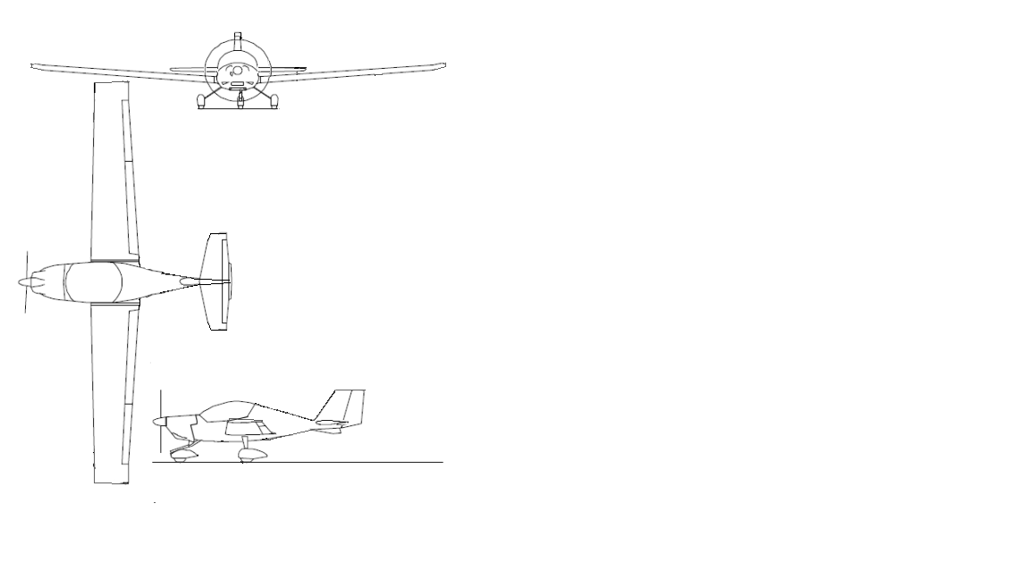

**+Fz**

**x**

**x**

**z**

**y**

**+Fy**

**y**

**+Fy**

**+My**

**+Mx**

**+Fx**

**+Fz**

**+Mz**

**+Fx**

**Figure 2** – Aeroplane reference axes

The origin is located at the airplane axis of symmetry (x axis) with the y axis passing through the leading edge of the mean aerodynamic chord section of the wing.

## Symmetrical flight conditions

The loads on the wing structure arising from symmetrical flight manoeuvres according to requirements 5.2.2 and 5.2.3 [3] are determined within this chapter.

The following abbreviations are used within this chapter (all measurements with respect to wing leading edge at wing mean aerodynamic chord, forces acting according to arrows are positive)

x longitudinal axis of the aircraft  
z vertical axis of the aircraft  
CG aircraft centre of gravity  
HT horizontal tail  
L lift force on the wings  
 horizontal tail balancing force (HT lift force)  
 zero lift wing pitching moment coefficient (lift force assumed to act on )  
 total pitching moment (must be zero for equilibrium)  
n W aircraft total weight force (= m*n*g )  
 distance to HT quarter chord line (of HT MAC as quarter chord line)  
 distance to aircraft centre of gravity  
 distance to wing fuselage combination centre of pressure  
 (lift force acting on not generating any pitching moment)  
 distance to wing fuselage combination aerodynamic centre  
 (lift force acting on generating constant pitching moment )

The external forces and moments acting on the aeroplane in a balanced flight condition have been determined. The simplified scheme in Figure **3** is considered. The aeroplane is reduced to the wing and the Horizontal tail.



**Figure 3** – Aeroplane simplified scheme

* The following forces are considered and placed in equilibrium:
  + Lift on the wing;
  + Horizontal tail balancing load according to requirement 5.2.2.1 [3];
  + Weight of the aeroplane;
* For the calculation of the equilibrium, the z-axis of the aeroplane is assumed aligned with the direction of the gravity. In a second stage (section 6.4), once the forces are calculated, the corresponding angle of attack will be considered for the calculation of the correct direction of the forces on the wing;
* Influence of thrust and drag (of the total airplane) are considered negligible at this stage of calculation of the vertical forces. The effect of the drag will be considered in a second stage on the wing only;
* The wing lift is assumed to act on the aerodynamic centre of the wing as a starting point. The contribution of the fuselage is accounted for as a shift of the point of aerodynamic centre. This is better explained in section 6.1.5.
* The HT lift is applied at 25% of the chord;
* Effects of structural flexure are considered negligible;
* Angular accelerations are disregarded until the aeroplane has attained the prescribed load factor (according to requirement 5.2.2.3 [3]);

*Note: The assumptions above provide a clear simplification to the calculations. The fact that they are used here does not mean that they can always be used. It is the responsibility of the designer to make the appropriate assumptions and to agree them with the Agency.*

Based on the above assumptions the following equilibrium equations are set. The basis system of equations include 4 equations with the following unknowns:

* L: wing Lift (including fuselage)
* CL: wing lift coefficient
* LHT: HT lift
* XAC f+w: aerodynamic centre w+f (wing + fuselage; see sec. 6.1.3 and 6.1.5)

1. Equilibrium of moments (f. 6.1.2.1)
2. Equilibrium of forces (f. 6.1.2.2)
3. wing pitching moment (f.6.1.2.3)  
   (for wing)
4. wing lift coefficient (f. 6.1.2.4)

## Aerodynamic centre

The aerodynamic centre is a characteristic of the wing and it is defined as the point about which the pitch moment does not change with changes of the angle of attack throughout the linear range of the lift curve.

According to [5] the aerodynamic centre can be estimated by adding a correction factor (shift) to the quarter chord point of the mean aerodynamic chord. The correction factor is a function of the maximum thickness of the profile which in this wing is 16% of the chord. For a tapered wing, the mean aerodynamic chord corresponds to the mean chord and it is (see [6]). For this wing the correction factor is 0.012 (from Fig.2 [5] at 16% thickness), so the mean aerodynamic centre of the wing without fuselage is

(f. 6.1.3.1)

## Pitching moment of the wing

The pitching moment of the profile from two dimensional wind tunnel test data [7] does not represent the moment of a three dimensional with the profile. The pitching moment of the whole wing is calculated according to DATCOM method 1 (formula 4.1.4.1.a [8]).

(formula 4.1.4.1.a [8]) (f. 6.1.4.1)

With quarter chord sweep angle of the wing .

## Influence of the fuselage

The fuselage is assumed to provide negligible lift. On the other hand, its influence on the aeroplane equilibrium is accounted for as a contribution to the pitching moment. In particular the following formula (taken from ref [9]) provides the shift of the aerodynamic centre of the wing due to fuselage pitching moment.

(f. 6.1.5.1)

With and as input to the diagram in [9] yielding and a correction factor of 1.05 due to low-wing configuration.

The shift of aerodynamic centre, due to the fuselage, is calculated as:

(f. 6.1.5.2)

## Forces and moments acting on the wings

In previous chapter the Lift and the lift coefficient have been determined. Having those as inputs, the drag and angle of attack are calculated.

Total wing drag coefficient (FIG. X2.1 of [3])(f. 6.2.1)

Drag force on the wings (FIG. X2.1 of [3]) (f. 6.2.2)

The angle of attack (using as reference instead of ) for each load case is calculated using the following formula:

(FIG. X2.1 of [3]) (f. 6.2.3)

Where:

lift curve slope (FIG. X2.1 of [3]) (f. 6.2.4)

and the zero-lift angle of the wing is taken as . This value is the zero-lift angle of the corresponding wing profile, taken from ref [7] (p.236).

The results of this chapter for the load cases highlighted in subchapter 0 are presented within the table below.

| **Load  case** | **Load** | **Weight** | **Wing lift  force** | **Angle  of attack** | **Lift coefficient** | **Drag  coefficient** | **Drag force** | **Horizontal tail lift force** |
| --- | --- | --- | --- | --- | --- | --- | --- | --- |
| # |  |  | L [N] | α [deg] | CL [] | CD[] | D [N] | L_ht [N] |
| LC1 | pos. manoeuvring @V_A | W_MTOW,aft | 22950 | 10,53 | 0,99 | 0,0508 | 1173 | 594 |
| LC2 | pos. manoeuvring @V_A | W_MTOW,fwd | 24168 | 11,20 | 1,05 | 0,0552 | 1276 | -624 |
| LC3 | pos. manoeuvring @V_A | W_ZWF,fwd | 24177 | 11,20 | 1,05 | 0,0552 | 1277 | -633 |
| LC4 | pos. manoeuvring @V_A | W_ZWF,aft | 22960 | 10,54 | 0,99 | 0,0508 | 1174 | 584 |
| LC5 | pos. manoeuvring @V_A | W_min,fwd | 18497 | 8,10 | 0,80 | 0,0365 | 843 | -604 |
| LC6 | pos. manoeuvring @V_A | W_min,aft | 16510 | 7,02 | 0,71 | 0,0311 | 719 | 285 |
| LC7 | pos. gust @V_C | W_MTOW,aft | 30104 | 9,42 | 0,90 | 0,0438 | 1459 | 711 |
| LC8 | pos. gust @V_C | W_MTOW,fwd | 31699 | 10,02 | 0,95 | 0,0475 | 1581 | -884 |
| LC9 | pos. gust @V_C | W_ZWF,fwd | 31710 | 10,02 | 0,95 | 0,0475 | 1582 | -895 |
| LC10 | pos. gust @V_C | W_ZWF,aft | 30118 | 9,42 | 0,91 | 0,0439 | 1460 | 697 |
| LC11 | pos. gust @V_C | W_min,fwd | 28215 | 8,70 | 0,85 | 0,0397 | 1322 | -878 |
| LC12 | pos. gust @V_C | W_min,aft | 26036 | 7,88 | 0,78 | 0,0353 | 1175 | 522 |
| LC13 | pos. gust @V_C | W_minFF | 28248 | 8,71 | 0,85 | 0,0398 | 1324 | 111 |
| LC14 | neg. gust @V_C | W_MTOW,aft | -17415 | -8,57 | -0,52 | 0,0213 | 710 | -1628 |
| LC15 | neg. gust @V_C | W_MTOW,fwd | -18401 | -8,95 | -0,55 | 0,0226 | 753 | -642 |
| LC16 | neg. gust @V_C | W_ZWF,fwd | -18408 | -8,95 | -0,55 | 0,0226 | 754 | -635 |
| LC17 | neg. gust @V_C | W_ZWF,aft | -17424 | -8,58 | -0,52 | 0,0213 | 710 | -1619 |
| LC18 | neg. gust @V_C | W_min,fwd | -17753 | -8,70 | -0,53 | 0,0218 | 724 | -638 |
| LC19 | neg. gust @V_C | W_min,aft | -16567 | -8,25 | -0,50 | 0,0202 | 674 | -1594 |
| LC20 | neg. gust @V_C | W_minFF | -17357 | -8,55 | -0,52 | 0,0212 | 707 | -1291 |
| LC21 | pos. manoeuvring @V_D | W_MTOW,aft | 23746 | 3,08 | 0,40 | 0,0167 | 986 | -202 |
| LC22 | pos. manoeuvring @V_D | W_MTOW,fwd | 24964 | 3,34 | 0,42 | 0,0174 | 1027 | -1420 |
| LC23 | pos. manoeuvring @V_D | W_ZWF,fwd | 24973 | 3,34 | 0,42 | 0,0174 | 1027 | -1429 |
| LC24 | pos. manoeuvring @V_D | W_ZWF,aft | 23756 | 3,08 | 0,40 | 0,0167 | 986 | -212 |
| LC25 | pos. manoeuvring @V_D | W_min,fwd | 19293 | 2,13 | 0,33 | 0,0144 | 852 | -1400 |
| LC26 | pos. manoeuvring @V_D | W_min,aft | 17306 | 1,71 | 0,29 | 0,0135 | 801 | -511 |
| LC27 | pos. gust @V_D | W_MTOW,aft | 22756 | 2,87 | 0,38 | 0,0161 | 953 | -250 |
| LC28 | pos. gust @V_D | W_MTOW,fwd | 23920 | 3,11 | 0,40 | 0,0168 | 991 | -1415 |
| LC29 | pos. gust @V_D | W_ZWF,fwd | 23929 | 3,12 | 0,40 | 0,0168 | 992 | -1423 |
| LC30 | pos. gust @V_D | W_ZWF,aft | 22766 | 2,87 | 0,38 | 0,0161 | 954 | -260 |
| LC31 | pos. gust @V_D | W_min,fwd | 21125 | 2,52 | 0,36 | 0,0153 | 903 | -1409 |
| LC32 | pos. gust @V_D | W_min,aft | 19507 | 2,17 | 0,33 | 0,0145 | 857 | -402 |
| LC33 | pos. gust @V_D | W_minFF | 21219 | 2,54 | 0,36 | 0,0153 | 906 | -694 |
| LC34 | neg. gust @V_D | W_MTOW,aft | -8924 | -3,88 | -0,15 | 0,0109 | 647 | -1809 |
| LC35 | neg. gust @V_D | W_MTOW,fwd | -9480 | -4,00 | -0,16 | 0,0111 | 654 | -1254 |
| LC36 | neg. gust @V_D | W_ZWF,fwd | -9483 | -4,00 | -0,16 | 0,0111 | 654 | -1250 |
| LC37 | neg. gust @V_D | W_ZWF,aft | -8929 | -3,88 | -0,15 | 0,0109 | 647 | -1805 |
| LC38 | neg. gust @V_D | W_min,fwd | -9520 | -4,01 | -0,16 | 0,0111 | 655 | -1250 |
| LC39 | neg. gust @V_D | W_min,aft | -8895 | -3,87 | -0,15 | 0,0109 | 647 | -1813 |
| LC40 | neg. gust @V_D | W_minFF | -9185 | -3,94 | -0,16 | 0,0110 | 651 | -1628 |
| LC41 | neg. manoeuvring @V_D | W_MTOW,aft | -9914 | -4,09 | -0,17 | 0,0112 | 660 | -1858 |
| LC42 | neg. manoeuvring @V_D | W_MTOW,fwd | -10523 | -4,22 | -0,18 | 0,0113 | 669 | -1249 |
| LC43 | neg. manoeuvring @V_D | W_ZWF,fwd | -10527 | -4,22 | -0,18 | 0,0113 | 669 | -1245 |
| LC44 | neg. manoeuvring @V_D | W_ZWF,aft | -9919 | -4,09 | -0,17 | 0,0112 | 660 | -1853 |
| LC45 | neg. manoeuvring @V_D | W_min,fwd | -7688 | -3,62 | -0,13 | 0,0107 | 633 | -1259 |
| LC46 | neg. manoeuvring @V_D | W_min,aft | -6694 | -3,40 | -0,11 | 0,0105 | 623 | -1703 |
| LC47 | neg. manoeuvring @V_G | W_MTOW,aft | -10963 | -13,83 | -0,94 | 0,0466 | 543 | -809 |
| LC48 | neg. manoeuvring @V_G | W_MTOW,fwd | -11572 | -14,49 | -0,99 | 0,0508 | 592 | -200 |
| LC49 | neg. manoeuvring @V_G | W_ZWF,fwd | -11576 | -14,50 | -0,99 | 0,0508 | 592 | -196 |
| LC50 | neg. manoeuvring @V_G | W_ZWF,aft | -10968 | -13,84 | -0,94 | 0,0466 | 543 | -804 |
| LC51 | neg. manoeuvring @V_G | W_min,fwd | -8736 | -11,43 | -0,75 | 0,0332 | 387 | -210 |
| LC52 | neg. manoeuvring @V_G | W_min,aft | -7743 | -10,35 | -0,66 | 0,0283 | 329 | -655 |

**Table 4** – Loads on the aeroplane

## Unsymmetrical flight conditions

Note: These load cases will not be calculated within this revision of the example document.

## Wing load distribution

After having calculated the total load on the wing, the load distribution is calculated and shown in the following sections.

Every load is assumed to act on the span wise centre of each station.

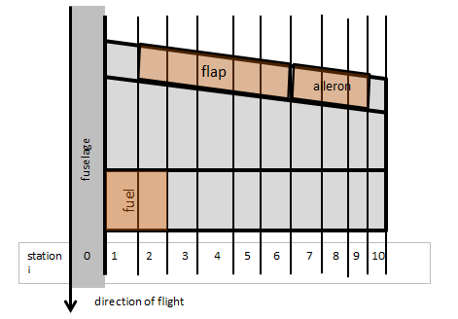

**Figure 4** – Location of wing stations

## Wing lift distribution

The wing lift distribution is calculated here. The lift contribution of the fuselage is assumed to be zero (this means that the load which would act in correspondence of the fuselage, is shifted externally to the wing) leading to more conservative results on the wing loads since they provide higher bending.

*Note: Alternatively, the applicant would have to determine the reduction in wing lift distribution at the location of the fuselage and demonstrate the validity of the approach.*

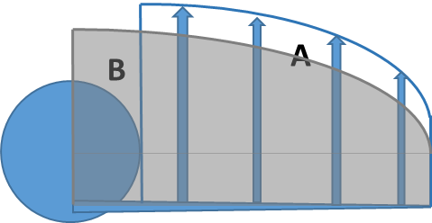

**Figure 5** – Effect of the fuselage, areas A (total lift calculated at the end of this chapter)   
and B (total lift according to Schrenk) are of equal size

This approach is based on the approximation described by Schrenk [10] and requires adjustments:

* moving the apex of the elliptical distribution from the fuselage centre towards the wing root
* increasing lift of wetted wing sections to compensate for zero lift of fuselage wing section

The formula for wing lift distribution is derived from Schrenk [10] and is altered to assume zero lift at the wing section within the fuselage as shown below. The formula gives the value of the lift for span unit. “i” identifies the individual station.

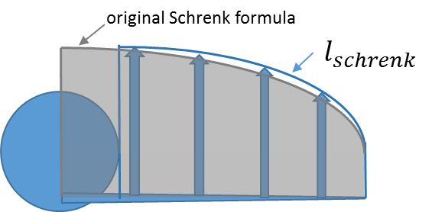

**Figure 6** – lift distribution with zero lift at fuselage wing section

( [10]) (f. 6.4.1.1)

Now the lift of the wing section within the fuselage is redistributed across the wetted wing area to achieve conservative results. The lift distribution calculated above is adjusted by multiplication of a correction factor derived from comparison between total lift of the whole wing including the fuselage section and the wetted wing only.

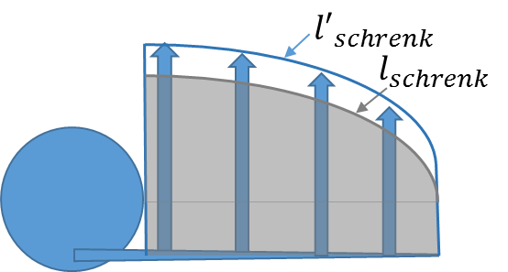

**Figure 7** – Fuselage wing section lift redistributed across wetted wing stations

or (f. 6.4.1.2)

The lift distribution corresponding to the formula above, gives a value of lift at wing tip which is higher than zero and therefore does not fully reproduce the actual loading (the winglift is normally zero at the tip). Nevertheless this assumption does not give significant changes and yields conservative results.

The local angle of attack for the station I, as a result of this corrected Schrenk distribution, is given by the following formula: (from f.6.2.3 and f.6.1.2.4) (f. 6.4.1.3)

*Note: FAA AC 23-19A, paragraph 23.301, contains other acceptable methods.*

**Figure 9** – Span wise lift distribution

## Wing drag distribution

Since the effect of the drag is negligible, when compared to the effect of the lift, the span wise drag distribution has been assumed constant throughout wing span. This is a conservative assumption. The drag loading per metre of span:

(f. 6.4.2.1)

## Wing and fuel mass distribution

The local masses are calculated for each wing station to account for the mass of the structure of the wing including the systems and control surfaces (control systems, and other equipment). It is assumed that the wing has a linear distribution proportional to the chord. At each station the point of application of the mass is 45% of the chord.

45% of the chord

main spar

direction of flight

**Figure 10** – Wing mass distribution

20 % of the chord

Station 2 rib

main spar

fuel

direction of flight

**Figure 11** – Fuel distribution

A constant fuel distribution (at a point of application of 20% of the chord) is assumed throughout the fuel tank span.

|  |  |  |  |  |  |
| --- | --- | --- | --- | --- | --- |
| Wing mass distribution with full fuel (40kg in each wing ) | | | | | |
| station | width | average span  at station | average chord  at station | mass of structure  at station | fuel mass  at station |
| # | Δy_i [m] | y_i [m] | c_i [m] | m_w_i [kg] | m_fl_i [kg] |
| 0 | 0.50 | 0.25 | 1.56 | fuselage |  |
| 1 | 0.50 | 0.75 | 1.53 | 5.6 | 20.0 |
| 2 | 0.50 | 1.25 | 1.50 | 5.5 | 20.0 |
| 3 | 0.50 | 1.75 | 1.47 | 5.4 | 0.0 |
| 4 | 0.50 | 2.25 | 1.44 | 5.3 | 0.0 |
| 5 | 0.50 | 2.75 | 1.41 | 5.2 | 0.0 |
| 6 | 0.50 | 3.25 | 1.38 | 5.1 | 0.0 |
| 7 | 0.50 | 3.75 | 1.35 | 5.0 | 0.0 |
| 8 | 0.50 | 4.25 | 1.32 | 4.9 | 0.0 |
| 9 | 0.50 | 4.75 | 1.30 | 4.8 | 0.0 |
| 10 | 0.39 | 5.20 | 1.27 | 3.7 | 0.0 |

**Table 5** – Mass distribution with full fuel

## Wing torsion distribution

At each station, the wing lift is assumed to be acting at the local centre of pressure, which is calculated using the formula:

(from eq. 9.17.(d) [11]) (f. 6.4.4.1)

Where, ci is the chord at each station, cm0_w_i is the pitching moment around the aerodynamic centre of the wing section (it is -0.0436 across the wing from chapter 6.1.4), CL_i is the local lift coefficient and comes from the corrected Schrenk distribution () in 6.1.5. Therefore centre of pressure location is dependent on the local angle of attack.

Each station’s lift force acts on its centre of pressure and imposes torsion around the wing elastic axis which for this aeroplane is located approximately at a constant chord percentage of 30% (see design data - the main spar is approximately at 25% of the chord) throughout the entire wing span with local positions as local shear centres at the stations.

*Note: the location of the elastic axis for this wing has been assumed at 30%. It is responsibility of the applicant to determine and justify the location of the elastic axis.*

Incremental torsion load on structure at each station with respect to local wing shear centre including contribution of fuel and wing structure inertia forces:

(f..2)

Torsion at each station i (with respect to shear centre) is:

(f. 6.4.4.3)

## Distribution of internal loads

The components of the internal loads on the wing structure are calculated in different steps for each station.

The flight load factor n is assumed to act in parallel to the direction of the lift force instead of the direction of the normal force (As required by 5.2.1.1 of ref. [3]). The difference is assumed negligible.

The incremental shear load parallel to lift force vector at station i is taking into account also the inertia unloading of the wing

(f. 6.4.5.1)

Incremental shear load parallel to drag force vector at station i:

(f. 6.4.5.2)

With representing the width of the station i.

The summation of incremental shear loads throughout the stations to obtain the absolute shear loads at station i is presented below.

Shear load parallel to lift force vector

(f..3)  
Shear load parallel to drag force vector

(f. 6.4.5.4)

The components of the loads along the normal and tangential directions are derived by using the following formulas and figure:

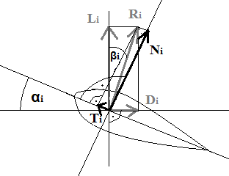

**Figure 12** – Forces components on the wing

(The tangential force is oriented opposite to the x axis and is therefore positive when directed towards the front of the aeroplane.)

Resulting force angle (f.6.4.5.5)   
Shear loads along the directions of:

resulting force (f. 6.4.5.6)

tangential force (f. 6.4.5.7)

normal force (f. 6.4.5.8)

With the local angle of attack for the station i as a result of the corrected Schrenk distribution given by the following formula: (from f. 6.4.1.4)

Summation of shear loads to obtain the bending moments at each station and using the increased lever arm ( instead of ) at the wing tip station results in slightly more conservative values.

Bending moment along normal direction

(f. 6.4.5.9)

Bending moment along tangential direction

(f. 6.4.5.10)

The results are presented within the graphs and tables below.

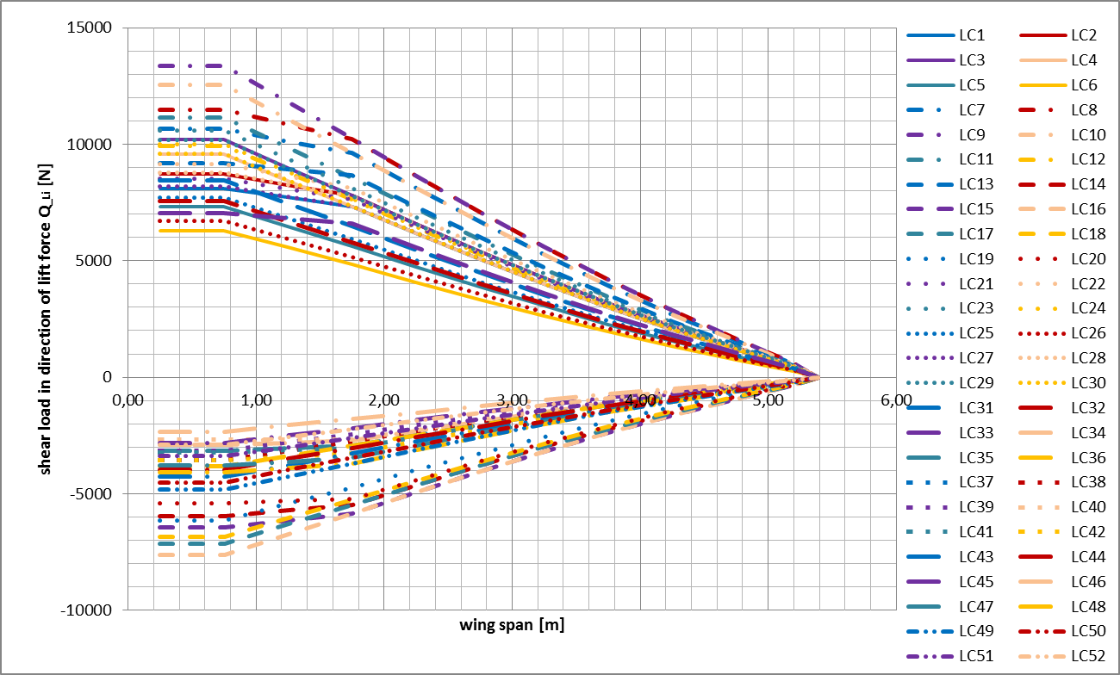

**Figure 13** – Shear load distribution in direction of lift force

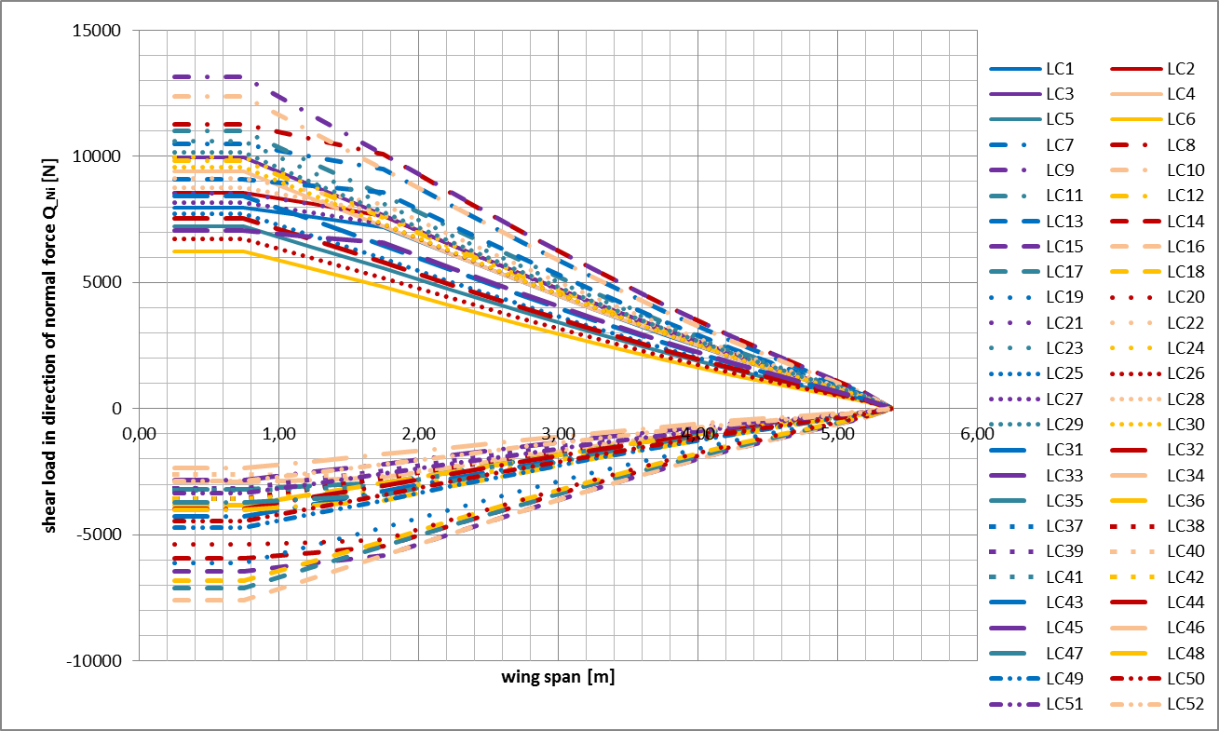

**Figure 14** – Shear load distribution in direction of normal force

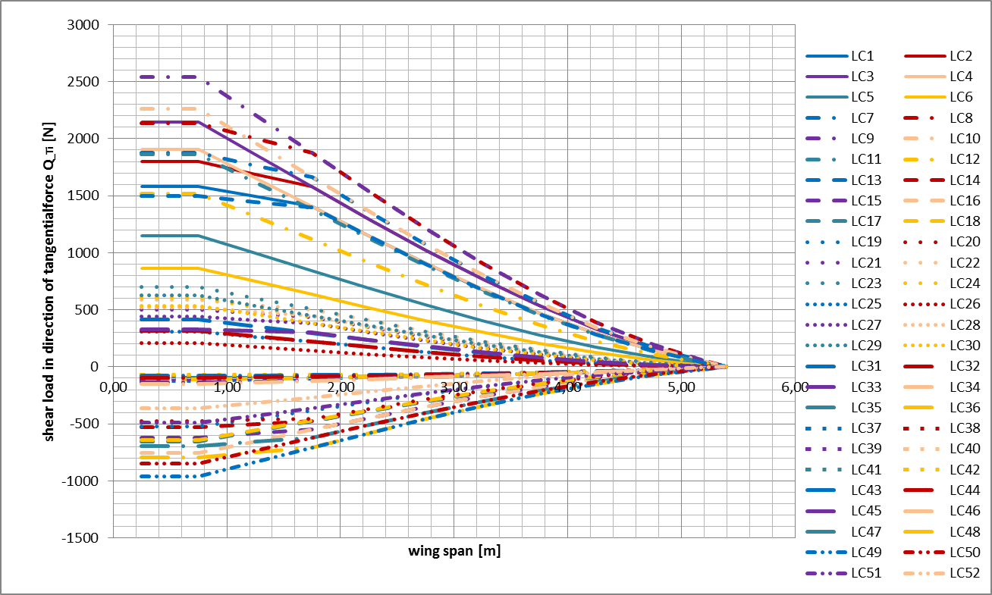

**Figure 15** – Shear load distribution in direction of tangential force bending moment distribution in direction of normal force

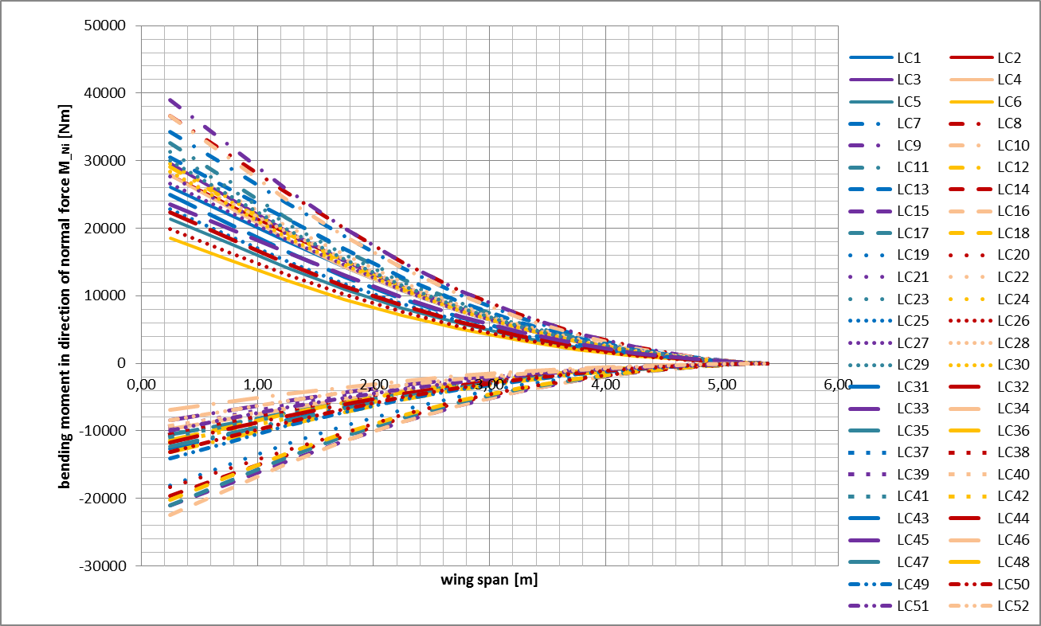

**Figure 16** – Bending moment distribution in direction of normal force

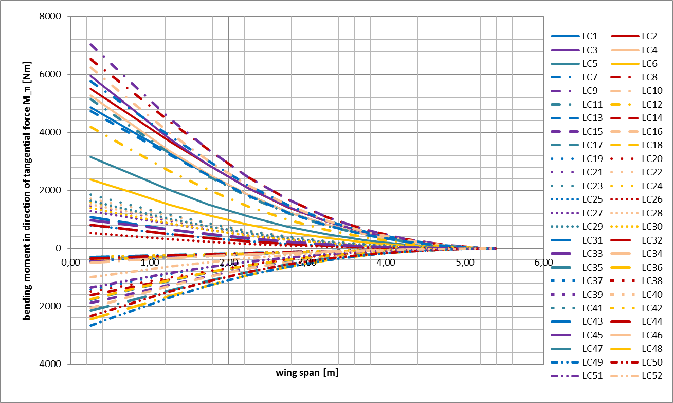

**Figure 17** – Bending moment distribution in direction of tangential force

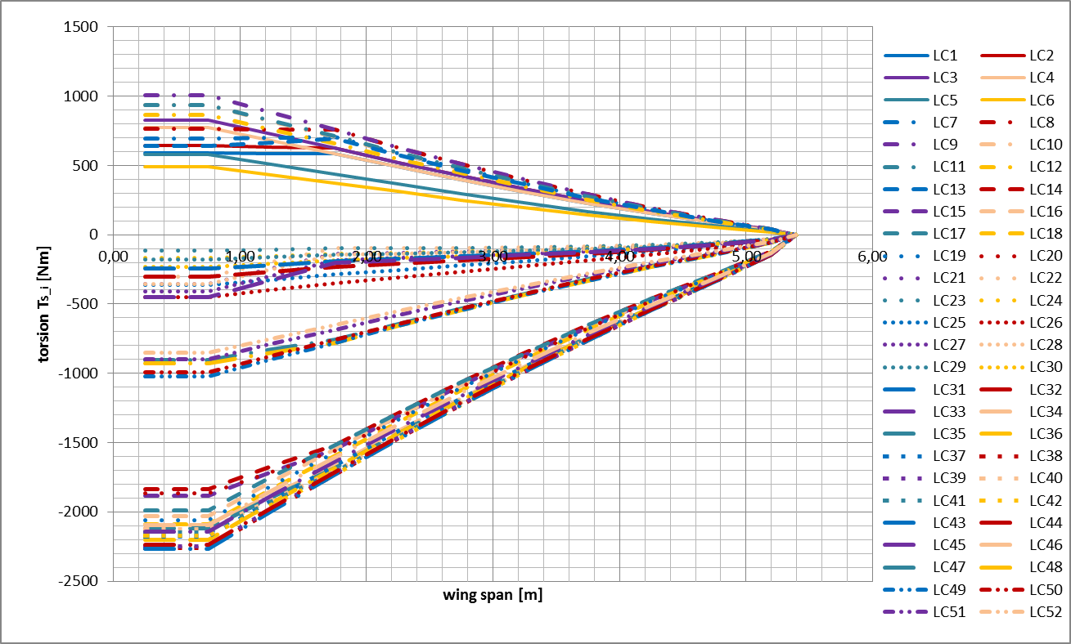

**Figure 18** – Torsion distribution with reference to wing elastic axis

## Compliance statements

Compliance statements are shown below:

|  |  |
| --- | --- |
| **Requirement reference** | **Subject** |
| CS-LSA F2245-12d  5.1.1.1 | 5.1.1.1 Strength requirements are specified in terms of limit loads (the maximum loads to be expected in service) and ultimate loads (limit loads multiplied by prescribed factors of safety). Unless otherwise provided, prescribed loads are limit loads. |
| **Statement of compliance** | Calculated loads are limit loads. See chapter 6. |

|  |  |
| --- | --- |
| **Requirement reference** | **Subject** |
| CS-LSA F2245-12d  5.1.1.2 | 5.1.1.2 Unless otherwise provided, the air, ground, and water loads must be placed in equilibrium with inertia forces, considering each item of mass in the airplane. These loads must be distributed to conservatively approximate or closely represent actual conditions. |
| **Statement of compliance** | Calculations are based on equilibrium of air and inertia forces.  Mass distribution is taken into consideration. See chapters 6.1, 6.2, 6.4 . |

|  |  |
| --- | --- |
| **Requirement reference** | **Subject** |
| CS-LSA F2245-12d  5.1.1.4 | 5.1.1.3 The simplified structural design criteria given in Appendix X1 may be used for airplanes with conventional configurations. If Appendix X1 is used, the entire appendix must be substituted for the corresponding paragraphs of this subpart, that is, 5.2.1 to 5.7.3. Appendix X2 contains acceptable methods of analysis that may be used for compliance with the loading requirements for the wings and fuselage. |
| **Statement of compliance** | The simplified design criteria is not used. |

|  |  |
| --- | --- |
| **Requirement reference** | **Subject** |
| CS-LSA F2245-12d  5.2.1.1 | 5.2.1.1 Flight load factors, n, represent the ratio of the aerodynamic force component (acting normal to the assumed longitudinal axis of the airplane) to the weight of the airplane. A positive flight load factor is one in which the aerodynamic force acts upward, with respect to the airplane. |
| **Statement of compliance** | The requirement has been met. This is shown in chapter 6.4.5. |

|  |  |
| --- | --- |
| **Requirement reference** | **Subject** |
| CS-LSA F2245-12d  5.2.1.2 | 5.2.1.2 Compliance with the flight load requirements of this section must be shown at each practicable combination of weight and disposable load within the operating limitations specified in the POH. |
| **Statement of compliance** | Every combination of weight and centre of gravity was considered. See chapter 6. |

|  |  |
| --- | --- |
| **Requirement reference** | **Subject** |
| CS-LSA F2245-12d  5.2.2.1 | 5.2.2.1 The appropriate balancing horizontal tail loads must be accounted for in a rational or conservative manner when determining the wing loads and linear inertia loads corresponding to any of the symmetrical flight conditions specified in 5.2.2 to 5.2.6. |
| **Statement of compliance** | Horizontal tail balancing, fuselage aerodynamic and inertia loads were considered in determining the wing loads. See chapter 6.1. |

|  |  |
| --- | --- |
| **Requirement reference** | **Subject** |
| CS-LSA F2245-12d  5.2.2.2 | 5.2.2.2 The incremental horizontal tail loads due to maneuvering and gusts must be reacted by the angular inertia of the airplane in a rational or conservative manner. |
| **Statement of compliance** | In calculating the loads on the wing in gust and manoeuvre, the angular inertia of the aeroplane has been disregarded. This is considered acceptable for the wing loads. See chapter 6.1. |

|  |  |
| --- | --- |
| **Requirement reference** | **Subject** |
| CS-LSA F2245-12d  5.2.2.3 | 5.2.2.3 In computing the loads arising in the conditions prescribed above, the angle of attack is assumed to be changed suddenly without loss of air speed until the prescribed load factor is attained. Angular accelerations may be disregarded. |
| **Statement of compliance** | The loss of speed has been has been disregarded and also the angular accelerations during symmetrical flight. See chapter 6.1. |

|  |  |
| --- | --- |
| **Requirement reference** | **Subject** |
| CS-LSA F2245-12d  5.2.2.4 | 5.2.2.4 The aerodynamic data required for establishing the loading conditions must be verified by tests, calculations, or by conservative estimation. In the absence of better information, the maximum negative lift coefficient for rigid lifting surfaces may be assumed to be equal to −0.80. If the pitching moment coefficient, *Cmo*, is less than ±0.025, a coefficient of at least ±0.025 must be used. |
| **Statement of compliance** | Aerodynamic data is sourced from conservative estimates based on tests [7].  Negative lift coefficient was sourced from aerodynamic tests [7].Moment coefficient Cmo is greater than ±0.025 (-0.055) [7]. See chapters 6.1, 6.2 and 6.4 . |

|  |  |
| --- | --- |
| **Requirement reference** | **Subject** |
| CS-LSA F2245-12d  5.2.3.1 | 5.2.3.1 *General* – Compliance with the strength requirements of this subpart must be shown at any combination of airspeed and load factor on and within the boundaries of a flight envelope similar to the one in Fig. 1 that represents the envelope of the flight loading conditions specified by the maneuvering and gust criteria of 5.2.5 and 5.2.6 respectively. |
| **Statement of compliance** | Every combination of airspeed and load factor on and within the boundaries of the flight envelope was considered. See chapter 6. |

|  |  |
| --- | --- |
| **Requirement reference** | **Subject** |
| CS-LSA F2245-12d  5.2.7 | 5.2.7 *Unsymmetrical Flight Conditions –* The airplane is assumed to be subjected to the unsymmetrical flight conditions of 5.2.7.1 and 5.2.7.2. Unbalanced aerodynamic moments about the centre of gravity must be reacted in a rational or conservative manner considering the principal masses furnishing the reacting inertia forces. |
| **Statement of compliance** | *Note: Unsymmetrical loads have not been calculated in this revision of the document* |

|  |  |
| --- | --- |
| **Requirement reference** | **Subject** |
| CS-LSA F2245-12d  5.2.7.1 | 5.2.7.1 *Rolling Conditions* – The airplane shall be designed for the loads resulting from the roll control deflections and speeds specified in 5.7.1 in combination with a load factor of at least two thirds of the positive maneuvering load factor prescribed in 5.2.5.1. The rolling accelerations may be obtained by the methods given in X2.3. The effect of the roll control displacement on the wing torsion may be accounted for by the method of X2.3.2 and X2.3.3. |
| **Statement of compliance** | *Note: Unsymmetrical loads have not been calculated in this revision of the document* |

|  |  |
| --- | --- |
| **Requirement reference** | **Subject** |
| CS-LSA F2245-12d  5.2.7.2 | 5.2.7.2 *Yawing Conditions* – The airplane must be designed for the yawing loads resulting from the vertical surface loads specified in 5.5. |
| **Statement of compliance** | *Note: Unsymmetrical loads have not been calculated in this revision of the document* |